–



***LIBRARY MANAGEMENT SYSTEM USING PYTHON AND MySQL***

**REVIEW REPORT**

*Submitted by*

**Shreyaans Nahata** [*19BCE2686*]

**M B Srinidhi** [*18BCB0104*]

**Suyasha Agrawal** [*19BCE0321*]

For

**DATABASE MANAGEMENT SYSTEMS (*CSE2004*)**

**PROJECT COMPONENT**

Submitted to

**Prof. Nancy Victor**

**School of Computer Science and Engineering**

**ABSTRACT**

With the need of informationization and modernization of colleges, more and more colleges choose to move towards the direction of digital library management. As a transmission center of information in colleges, library plays a vital role in the dissemination of knowledge and spiritual civilization. The level of library construction is closely related to the quality of teaching in colleges

The Library Management System is an application for assisting a librarian in managing a book library. The system would provide basic set of features to add/update members, add/update books, and manage check in specifications for the systems based on the client’s statement of need.

A Library management system is a typical management Information system (MIS), its Development include the establishment and maintenance of back-end database and front-end application development aspects. For the former require the establishment of data consistency and integrity of the strong data security and good libraries. As for the latter requires the application fully functional, easy to use and so on.

One such effective system is our Library Management System which will be designed using the latest open-source technology. Our focus is to provide a lightweight application which is easy to use even for the least experienced user and provides basic functionality such as add books, remove books, edit book details, edit user details, add users, add/remove authors, publishers, categories and maintain records for various activities such as borrowed books and due dates and such.

We also intend to draw focus on presenting the database information in an easy and intelligible manner. The application will also feature password authentication so that the users can access their records and issue books from the library but will not be able to change any database details.

**TABLE OF CONTENTS**

|  |
| --- |
| **CHAPTER PAGE NO** |
| **Abstract 02** |
| 1. **Literature Survey 04** |
| 2. **Introduction 05**  2.1 Overview 05  2.2 Motivation 05  2.3 Objective 05-06  2.4 Organization of the Project 06 |
| 3. **Proposed Design of the Project 07**  3.1 ER Diagram 07  3.2 ER to Relational Mapping (Schema Diagram) 07  3.3 Tables and Constraints 08 |
| 4. **Project Resource Requirements 09**  4.1 Software Requirements 09  4.2 Hardware Requirements 09 |
| 5. **Conclusion 09** |
| **References 10** |

**LITERATURE SURVEY**

***Amin (2003)*** in his trend report provides information about various open source software for use in libraries like, software tools for automation, software tools for value added services, software tools for digital library initiatives, miscellaneous supporting tools.

***Eby (2007)*** lists and provides information on some of the available open source library management systems, digital library software, metasearch, link resolvers, federated search engines and OPAC software.

***Hofmann & Yang (2012)*** studies the current usage of next generation online public access catalogs and discovery tools in academic libraries in the USA and Canada. They also reports that use of discovery tool is increasing. The author also provides update on next generation catalog and discovery tool usage in academic libraries of both countries.

***Dartmouth College Library report (2013***) describes shortcomings of the present generation of library management systems and suggests improvements and inclusion of features in next generation systems like discovery, personalization, Reuse: Export, Tools, Assessment and analytics, collection development: metadata creation and 24 management, collection management, electronic resource management system, system integration.

***Yang (2013)*** describes advanced features of next generation library management systems such as interoperability, electronic resource management, knowledge base, role based login, unified workflow, license management, user driven acquisition, trial database management and other features such as RDA compatibility, support for different record formats, direct chat with vendor, ILL, integration with other system, clientless and cloud based. He also compares features of next generation LMSs such as Alma, Intota, Kuali OLE, Sierra and Worldshare.

***Palmer & Choi (2014)*** assesses the state of open source software research in the library context by employing descriptive literature review. They found that most of the significant areas of research are digital repository software, OPAC and integrated library systems.

**INTRODUCTION**

* 1. **Overview**

With the rapid development of computer technology, the application of computer technology in all walks of life has been widely popular. The development of modern information technology has led to the progress of the library in the direction of automation, network, and digitization. Due to the increase in the collection of library books and the increasing demand for information, the traditional manual management methods have many shortcomings, the main performance is that the efficiency of handling of borrowing books and returning books process is very low, obviously it cannot adapt to the current information society.

* 1. **Motivation**

We chose to implement a Library Management System since even though there are a lot of proprietary library management applications out there, most of which have a very unintuitive User Interface (UI) and may also lack many functions. We wish to make an application with an *intuitive UI*, along with functionality such as simplicity in use, lightweight and minimal use of system resources, ease of installation and other features such as *Dark Mode* and *Light Mode* support.

* 1. **Objective**

The Library Management System is an application for assisting a librarian in managing a book library. The system would provide basic set of features to add/update members, add/update books, and manage check in specifications for the systems based on the client’s statement of need.

The proposed system is an automated Library Management System. Through our application, user can add books, search books, update/edit information, add/edit information about authors, publishers, and various categories.

Our proposed system has the following advantages:

* User Friendly Interface
* Fast access to Database
* Less chance of Error
* More Storage Capacity
* Less Resource Use
* Dark and Light Mode functionality

All the manual difficulties in managing the Library will be rectified by implementing computerization.

The application will be made entirely using MySQL, Python and PyQt5 (a Python framework). MySQL comprises of the back-end, which holds the database. Python will be used for both front-end and back-end while the GUI for the application will be made using PyQt5.

* 1. **Organization of the Project**

|  |  |  |
| --- | --- | --- |
| **Reg. No.** | **Name** | **Work Assigned** |
| 19BCE2686 | Shreyaans Nahata | Creating GUI using PyQt5 and linking to the Python modules |
| 18BCB0104 | M B Srinidhi | Creating the database schema and populating with sample data |
| 19BCE0321 | Suyasha Agrawal | Creating Python modules and linking with MySQL database |

**PROPOSED DESIGN OF THE PROJECT**

**3.1 Entity-Relationship Diagram**

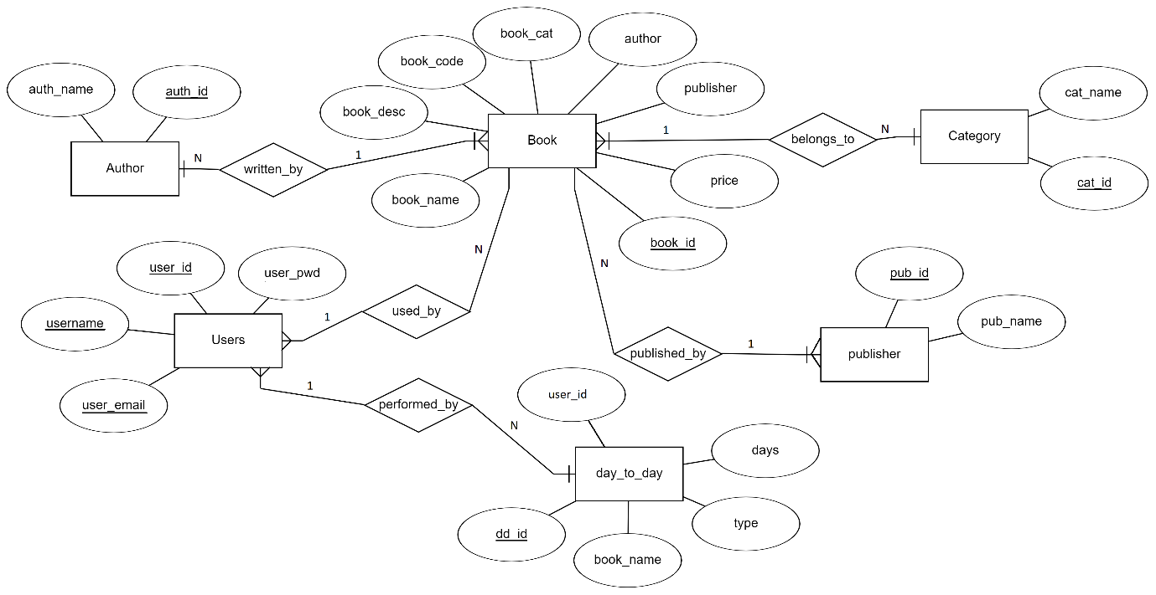

**3.2 ER to Relational Mapping (Schema Diagram)**

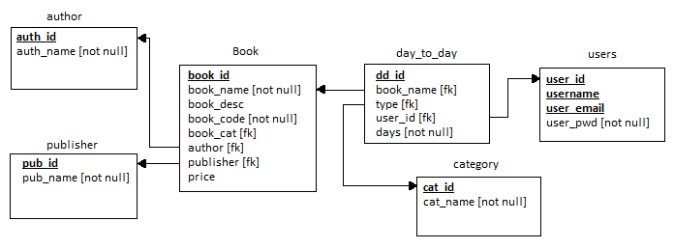

Book (book_id, book_name, book_desc, book_cat, author, publisher, price)

Users (user_id, username, user_email, user_pwd)

day_to_day (dd_id, book_id, operation, user_id, days)

category (cat_id, cat_name)

author (auth_id, auth_name)

publisher (pub_id, pub_name)

**3.3 Tables and Constraints**

|  |  |  |  |
| --- | --- | --- | --- |
| **TABLE** | **ATTRIBUTE** | **DATATYPE** | **CONSTRAINT** |
| **Book** | book_id | int | primary key |
| book_name | varchar | not null |
| book_desc | varchar |  |
| Category | varchar | foreign key category (cat_id) |
| Author | varchar | foreign key author (auth_id) |
| Publisher | varchar | foreign key pub(pub_id) |
| Price | int |  |
|  | | | |
| **Users** | user_id | int | primary key |
| username | varchar | Unique |
| user_email | varchar | unique |
| user_pwd | varchar | not null |
|  | | | |
| **day_to_day** | dd_id | int | primary key |
| Book_id | int | foreign key Book (book_id) |
| operation | varchar |  |
| user_id | int | foreign key Users (user_id) |
| days | int | not null |
|  | | | |
| **category** | cat_id | varchar | primary key |
| cat_name | varchar | not null |
|  | | | |
| **author** | auth_id | varchar | primary key |
| auth_name | varchar | not null |
|  | | | |
| **publisher** | pub_id | varchar | primary key |
| pub_name | varchar | not null |

**PROJECT RESOURCE REQUIREMENTS**

**4.1 Software Requirements**

Database using:MySQL and Python3

Graphical User Interface using: PyQt5

**4.2 Hardware Requirements**

A laptop/desktop with at least:

* A dual-core CPU.
* 4 GB RAM.
* Windows/MacOS/Linux with MySQL installed.
* 100MB free storage.
* Internet Connection.

**CONCLUSION**

Our library management System allows the user to store a large amount of information effectively and removes data redundancy. It also provides a user-friendly interface to let the end user interact with the database effectively without having to familiarize himself with the underlying technical details. This implementation of the system reduces the data entry time by a significant margin compared to using a more basic system. Another advantage is the reduction in human errors and the increase in efficiency. This overall reduces the human effort required.

The books are uniquely identified in our system and all the logs efficiently recorded. Hence making the search operation possible and effortless requiring just the press of a button. The information is thus accessed correctly and is without errors.

The system hence overcomes many of its predecessors’ shortcomings with its simplistic approach to its underlying database and minimalistic as well as aesthetic user interface providing functionalities such as light and dark mode for user comfort. Hence it is expected that this project will go a long way in satisfying user requirements and will increase efficiency while decreasing the stress of the database end users improving the overall human resources utilization.

**REFERENCES**

[**01**] *Shasha Yu, Enhai Qiu and Mei Zhou*, “**Research on Library Management System Based on Java**”, Advances in Computer Science Research, Vol. 82, pp. 946-949, 2017

[**02**] *Roknuzzaman M, Kanai H, Umemoto K*, “**Integration of knowledge management process into digital library system**”, Library Review, 2013.

[**03**] *Seena S T, Pillaiw K G S*, “**A study of ICT skills among library professionals in the Kerala University Library System**”, Annals of Library & Information Studies, 2014.

[**04**] *Taole N, Dick A L*, “**Implementing a common library system for the Lesotho Library Consortium**”. Electronic Library, 2013.

[**05**] *Chen M, Cai W, Ma L*, “**Cloud Computing Platform for an Online Model Library System**”, Mathematical Problems in Engineering, 2013.

[**06**] *Hall K, Ames C M, Brice J*, “**Open Source Library Software Development in a Small Rural Library System**”, Code4lib Journal, 2013.

[**07**] *Uppal V, Chindwani G*, “**An Empirical Study of Application of Data Mining Techniques in Library System**”, Journal of Bacteriology, 2014.

[**08**] *Rao N S, Kumari N N*, “**Revitalisation of Public Library System in India: A CSR Perspective**”, Desidoc Journal of Library & Information Technology, 2013.

[**09**] *Pu Y H, Chiu P S, Chen T S*, et al. “**The design and implementation of a Mobile Library APP system**”. Library Hi Tech, 2015.

[**10**] *Iorio A D, Schaerf M*, “**The Organization information integration in the management of a Digital Library System**”, Digital Libraries. IEEE.

[**11**] *Fems, Seimiekumo Solomon, Zifawei O. Kennedy, George Deinbofa, Oberhiri Oruma Godwin* (2019), “**Design And Implementation Of Digital Library Management System. A Case Study Of The Niger Delta University, Bayelsa State**”, International Journal of Scientific and Research Publications (IJSRP) 9(12)

[**12**] *Li, H., & Cai, Z.-Q*, “**Design and implementation of the mobile library app based on smart phone**”, 2016 International Conference on Machine Learning and Cybernetics (ICMLC), 2016.